Integrated Science Center Sinks
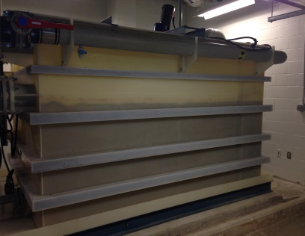
pH Neutralization System
The ISC is equipped with a neutralization system that treats all wastewater to ensure it is within the appropriate pH range. The system supplied is a flow-thru, single state, pH neutralization system. It is designed to accept continuous wastewater flow, up to 20.0 gallons per minute. A single stage 450 gallon pH treatment tank, located in the mechanical room on the ground, utilizes a single pH sensor located in the tank to detect the pH level of the wastewater.
The presence of the pH neutralization system eliminates adverse environment and health impacts, and prevents chemical discharges onto the streets, storm drains and to the beaches of the Chesapeake Bay.

What Can Go Down the Sinks?
- Liquids only:
  - Weak acids and bases may be poured down the drain, provided they contain no heavy metal salts or other toxins.

What NOT to put Down the Drain
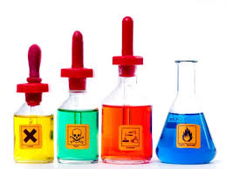
- No acute toxins may go down the drain.
- No volatile organic solvents may go down the drain.
- No solids, sludges, laboratory supplies or viscous materials
- No Resource Conservation and Recovery Act (RCRA) hazardous waste
  - Examples of RCRA waste:
    - Corrosives (pH less than 2 or greater than 12.5)
    - Flammables
    - Oxidizers (i.e. chromic acid, hydrogen peroxide)
    - Unused and/or outdated chemicals.
- No Metals containing wastes
- No volatile or corrosive materials; these substances damage piping and may endanger the health and safety of workers.
- Any quantity greater than that delivered by a spray bottle is prohibited.

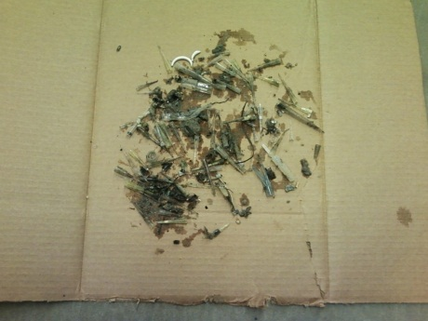
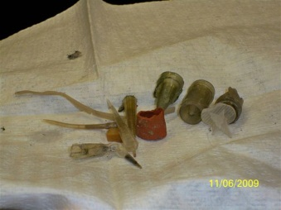
Sink Drains Safety Practices
Nonessential items recovered from the pH Neutralization system pumps.
Over the years, nonessential items (eppendorfs, magnetic stirrers, test tubes) have been placed down the lab sink drains, and recovered in the pH neutralization system pumps. To avoid mechanic damage to the pH neutralization system, labs should employ sink drain screens and mesh
screens.
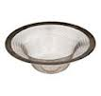
- Utilization of sink drain and mesh screens hinder objects from entering into the pH neutralization system
- Mesh screens prevents the sink drain screens from becoming dislodged, when a high flow of liquid is poured into the sink.

Disposal of Chemicals

- Contact EH&S to schedule a chemical waste pickup.

http://www.wm.edu/offices/facilities/documents/safety/isc/ph-system-om.pdf
http://www.oseh.umich.edu/hazmats/draindisposal

